S3 – GROUP BY - AVG -SUM

# What you will know:

GROUP BY – AVG - SUM

# Instructions: Open [this online SQL editor](https://www.w3schools.com/sql/trysql.asp?filename=trysql_op_in)

**Exercise 1: Databases on W3school**

Each product of **Products** table has a **category ID** (*this ID refers to an element in the* ***Categories*** *table*)

## Q1 : Write a SQL query to display the **number of products per category**.

Expected columns:

CategoryID Number of items

**SELECT categoryID, count(productname) as "Number of Products" FROM Products group by (categoryID);**

## Q2: Write a SQL query to display the **average price** of items per category ID.

Expected columns:

CategoryID Average items price

**Your query: SELECT CategoryID, avg(Price) FROM Products group by( CategoryID);**

…………………………………………………………………………………………………………………………………………………………….

## Q3: Write a SQL query to display the **total of the price** of all items per category ID.

Expected columns:

Category ID Total items price

**Your query: SELECT CategoryID, sum(Price) FROM Products group by( CategoryID);**

…………………………………………………………………………………………………………………………………………………………….

**Exercise 2: World Table**

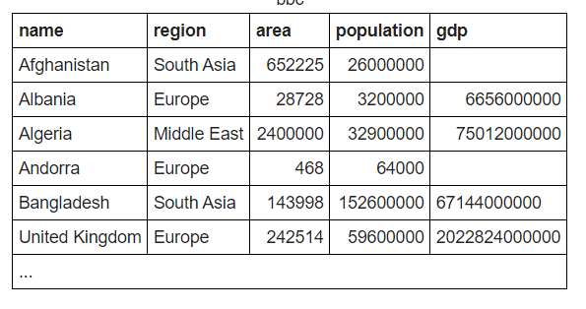

**Q1:** write a statement to sum of population of all countries.

**Your query: SELECT name, sum(population) FROM countries group by (name);**

**Q2** : write a statement to sum of population of all countries in «South Asia»

**Your query: SELECT sum(population) FROM south asia;**

**Q3:** write a statement to count GDP is null

**Your query: SELECT count(gdp) FROM countries group by (name);**

**Q4**: Write a statemet to showthe number of countries in each continent and group by continents:

**Your query: SELECT region, count(name) FROM worldtable group by (region);**

**Q5** : write a statement to show the total population in each continent, group by continents :

**Your query: SELECT sum(population) FROM worldTable group by (region )**

**Q6 :** For each relevant continent show the number of countries that has a population of at least 200000000.

**Your query: SELECT count(worldname) FROM worldTable where population =>**200000000.

Top of Form